Continuous Distribution Using SPSS

Question 1:

# Aim:

In 2008, the per capita consumption of coffee in Sweden was reported to be 8.2 kg, or 18.04 pounds. Assume that the per capita consumption of coffee in Sweden is approximately distributed as a normal random variable, with a mean of 18.04 pounds and a standard deviation of 5 pounds.

1. What is the probability that someone in Sweden consumed more than 10 pounds of coffee in 2008?
2. What is the probability that someone in Sweden consumed between 3 and 5 pounds of coffee in 2008?
3. What is the probability that someone in Sweden consumed less than 5 pounds of coffee in 2008?

# Procedure:

1. Open a new SPSS file.
2. In the variable view, define a variable (x) to act as the normal random variable. (It should be a scale variable and increase the decimal spaces)
3. In order to obtain the required the figures, the cumulative distribution function values when x = 3,5 and 10 is required.
4. In the variable view, enter the values of x under the ‘x’ column.
5. Now, in the “Transform” dropdown list, click on the “Compute Variable…”option.
6. In the dropdown box, enter a name for the target variable (CDF).
7. Choose the “CDF & Noncentral CDF” function group and since it a normal random variable, choose the “Cdf.Normal” option in the “Functions and Special Variables list”.
8. Edit the numeric expression (CDF.NORMAL(quant, mean, stddev)) and then finally click on “Ok.”
9. The statistics to obtain the required figures have been obtained.

# Calculations:

The statistics required to obtain the required figures are shown in the SPSS figure below:

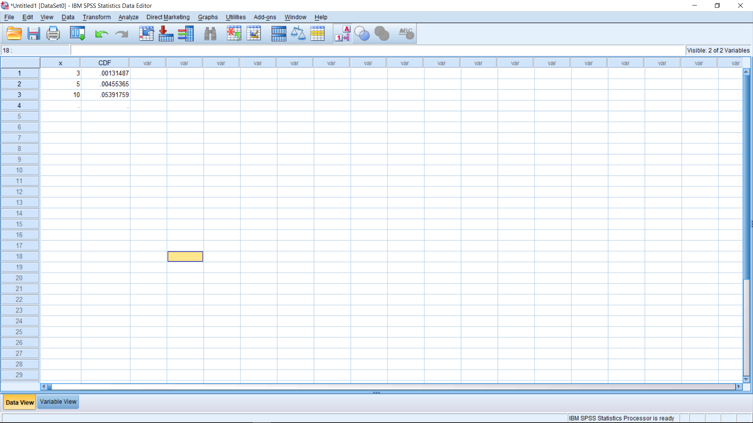

The probability that someone in Sweden consumed:

1. More than 10 pounds of coffee in 2008 is = 1 – CDF(x=10) = 1 - 0.0539 = 0.9461
2. Between 3 and 5 pounds of coffee in 2008 is = CDF(x=5) – CDF(x=3) = 0.0046 – 0.0013 = 0.0033
3. Less than 5 pounds of coffee in 2008 is = CDF(x=5) = 0.0046

# Conclusion:

With the help of SPSS, the cumulative distribution function for various values of the normal random variable can be calculated at ease.

Probability calculations related to a normal distribution can be done using SPSS.

Question 2:

# Aim:

Consumers spend an average of $21 per week in cash without being aware of where it goes. Assume that the amount of cash spent without being aware of where it goes is normally distributed and that the standard deviation is $5. Obtain the probability that a randomly selected person will spend:

(i) more than $25, (ii) between $10 and $20, (iii) less than $30.

Question 3:

# Aim:

A certain kind of equipment requires repairs on the average once in two years. Assuming that the time between repairs are exponentially distributed, what is the probability that such an equipment will work (i) at least 3 years without requiring repairs, (ii) at most two years without requiring repairs and (iii) between 2 to 4 years.

Question 4:

# Aim:

The duration of telephone conversations has been found to have an exponential distribution with mean 3 minutes. Find the probability that the conversation may last (i) more than 2 min, (ii) less than 4 min.

# Procedure:

1. Open a new SPSS file.
2. In the variable view, define a variable (x) to act as the random variable. (It should be a scale variable and increase the decimal spaces)
3. In order to obtain the required the figures, the cumulative distribution function values when x = 2and 4 is required.
4. In the variable view, enter the values of x under the ‘x’ column.
5. Now, in the “Transform” dropdown list, click on the “Compute Variable…” option.
6. In the dropdown box, enter a name for the target variable (CDF).
7. Choose the “CDF & Noncentral CDF” function group and since it a normal random variable, choose the “Cdf.Exp” option in the “Functions and Special Variables list”.
8. Edit the numeric expression (CDF.EXP (quant, scale)) and then finally click on “Ok.”
9. The statistics to obtain the required figures have been obtained.

# Calculations:

The statistics required to obtain the required figures are shown in the SPSS figure below:

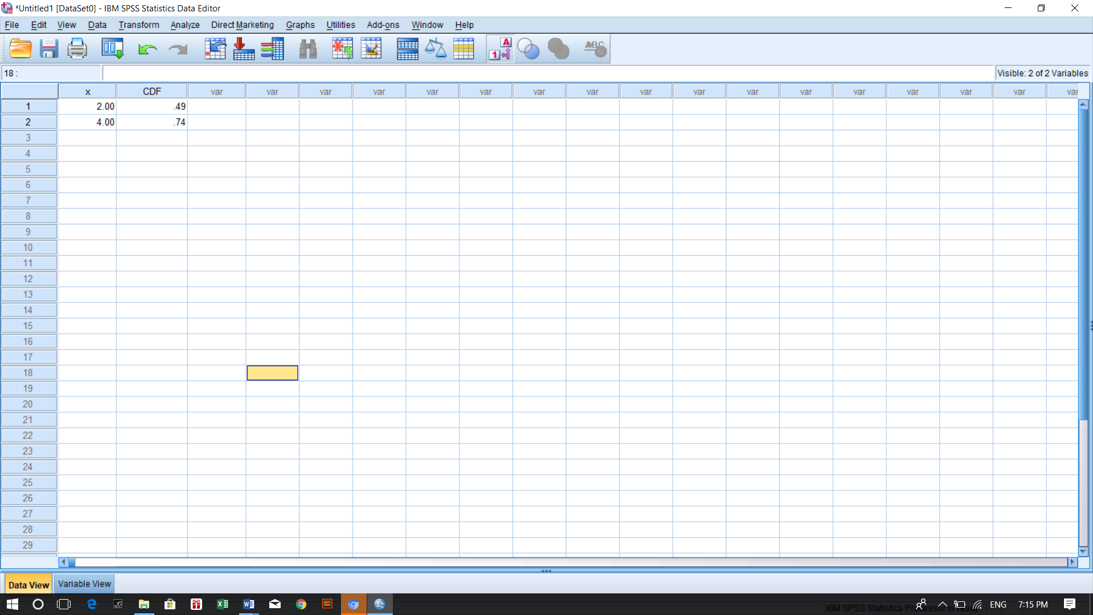

The probability that the conversation may last:

1. More than 2 mins is = 1 – CDF(x=2) = 1 – 0.49 = 0.51
2. Less than 4 mins is = CDF(x=4) = 0.74

# Conclusion:

With the help of SPSS, the cumulative distribution function for various values of the random variable of an exponential distribution can be calculated at ease.

Probability calculations related to an exponential distribution can be done using SPSS.

Question 5:

# Aim:

The daily consumption of milk in a city, in excess of 20,000 litres, is approximately distributed as a gamma variate with parameters a= 1/10000 and λ = 2. The city has a daily stock of 30,000 litres. Find the probability that the stock is insufficient on a particular day.

# Procedure:

1. Open a new SPSS file.
2. In the variable view, define a variable (x) to act as the random variable. (It should be a scale variable and increase the decimal spaces)
3. In order to obtain the required the figures, the cumulative distribution function values when x = 10000 is required.
4. In the variable view, enter the values of x under the ‘x’ column.
5. Now, in the “Transform” dropdown list, click on the “Compute Variable…” option.
6. In the dropdown box, enter a name for the target variable (CDF).
7. Choose the “CDF & Noncentral CDF” function group and since it a normal random variable, choose the “Cdf.Gamma” option in the “Functions and Special Variables list”.
8. Edit the numeric expression (CDF.GAMMA (quant, shape, scale)) and then finally click on “Ok.”
9. The statistics to obtain the required figures have been obtained.

# Calculations:

Figures required are:

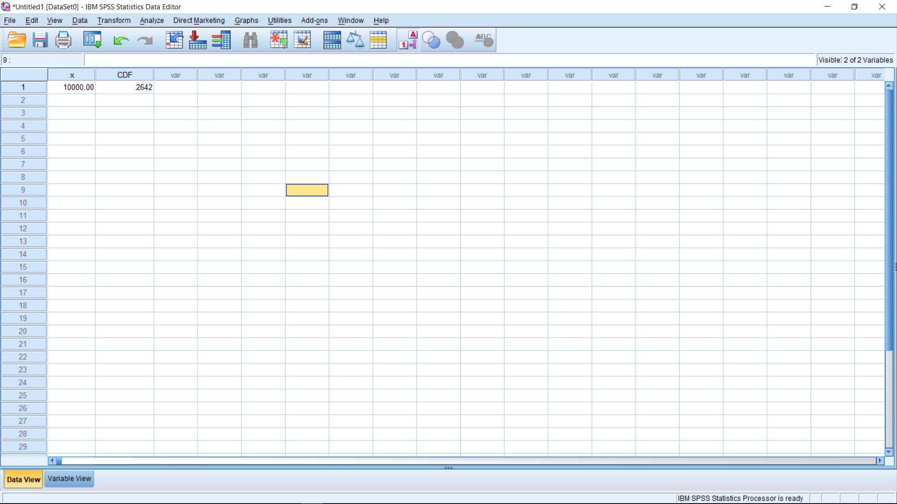

The probability that the stock will be insufficient is = 1 – 0.2642 = 0.7358

# Conclusion:

With the help of SPSS, the cumulative distribution function for various values of the random variable of a gamma distribution can be calculated at ease.

Probability calculations related to a gamma distribution can be done using SPSS.

-